***Creation of base table and dml operations***

Create table my_employee(ID number(4),Last_name varchar (25),First_name varchar(25),userid varchar(25),salary number(9,2));

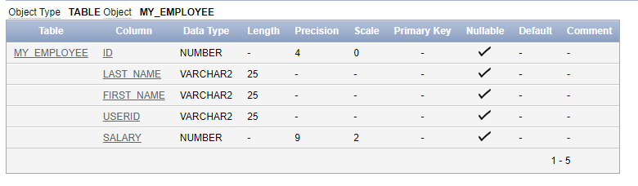

insert into my_employee(Id,Last_name,First_name,userid,salary) values(1,'patel','Ralph','rpatel',895);

insert into my_employee(Id,Last_name,First_name,userid,salary) values (2,'dancs','betty','bdancs',860);

insert into my_employee(Id,Last_name,First_name,salary) values (3,'Biri','Ben',1100);

insert into my_employee(Id,Last_name,First_name,salary) values (4,'Newman','chad',750);

update my_employee

set userid= SUBSTR(first_name, 1, 1) || SUBSTR(last_name,1, 7)

Select *from my_employee

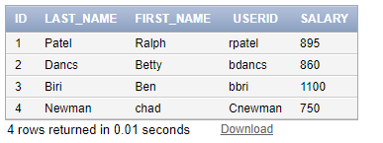

delete from my_employee where first_name='Betty';

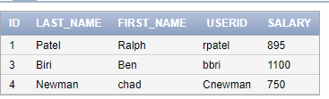

delete from my_employee where ID=4;

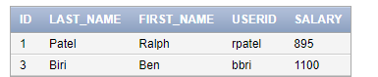

commit;

update my_employee set last_name='Drexler' where ID=3;

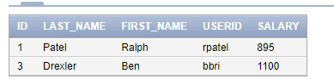

update my_employee set salary=1000 where salary<900;

